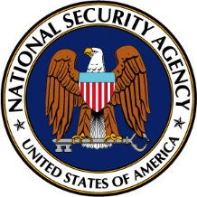

Certificate of Recognition 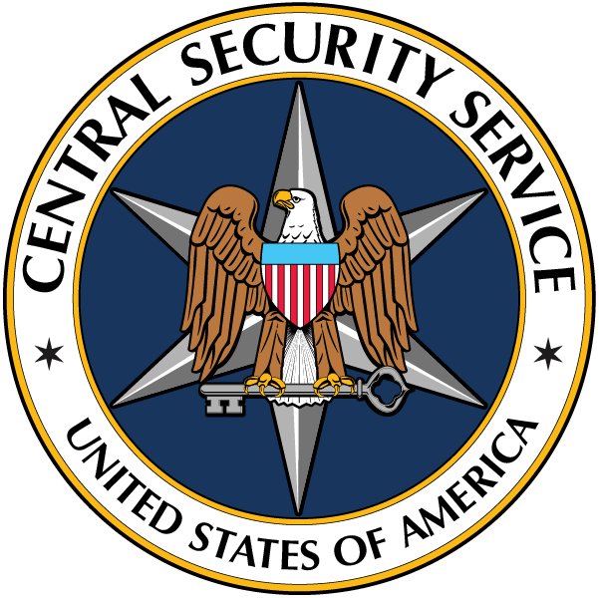

is given to

NAME/ORGANIZATION

National Security Agency, Frank B. Rowlett Award, 2023

The citation will be used to present the award at the award ceremony and should be a summary of the accomplishments in the nomination. The citation needs to remain unclassified

